STATEMENT OF WORK

|  |  |
| --- | --- |
| Topics | Page |
|  |  |
| * Indexing | 1 |
|  |  |
| * PROJECT Title & MEMBERS | 2 |
|  |  |
| * Objectives | 3 |
|  |  |
| * Data Information | 3 |
|  |  |
| * Solution Design | 4 |
|  |  |
| * Technology Stack | 4 |
|  |  |
| * Project Timeline | 5 |
|  |  |
| * Declaration | 6 |
|  |  |

PROJECT TOPIC

**Wheat Seed Classification**

PROJECT MEMBERS

|  |  |
| --- | --- |
| ***MEMBER NAME*** | ***STUDENT ID*** |
| Smriti Raina | 100830255 |
| Vaibhavi Thakkar | 100833169 |
| Shrutika Raut | 100844617 |

OBJECTIVES

The objective of the project is to recognize the varieties of wheat based on the morphology. Multiple classification algorithms will be used to determine the type of wheat (namely, Kama, Rosa and Canadian) for best accuracy.

DATA INFORMATION

<https://www.kaggle.com/jmcaro/wheat-seedsuci>

This data was acquired from the 'UCI Center for Machine Learning' repository. It contains seven variables for three distinct types of wheat kernels: (*Kama*, *Rosa*, *Canadian*) designated as numerical variables 1, 2 & 3 respectively. The seven seed variables are:

1. Area
2. Perimeter
3. Compactness
4. Kernel Length
5. Kernel Width
6. Asymmetry Coefficient
7. Kernel Groove Length

All these parameters are continuous and real valued.

The last column is reserved for the Kernel type. This dataset has 199 entries. Some of these variables are explicitly dependent. For example, *compactness*: C = 4*pi*Area/(Perimeter)^2 has a linear proportional relationship with *area*, and a square proportionality with *kernel width.*

SOLUTION DESIGN

***System Architecture***

TECHNOLOGY STACK

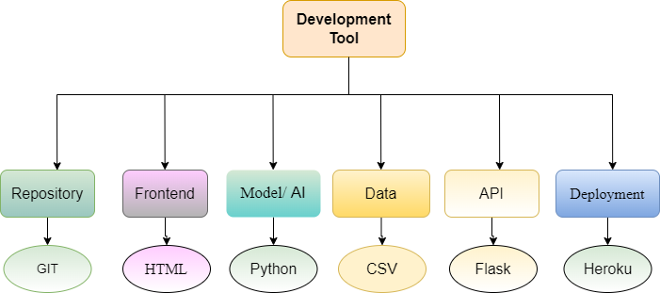

***Software tools***

PROJECT TIMELINE

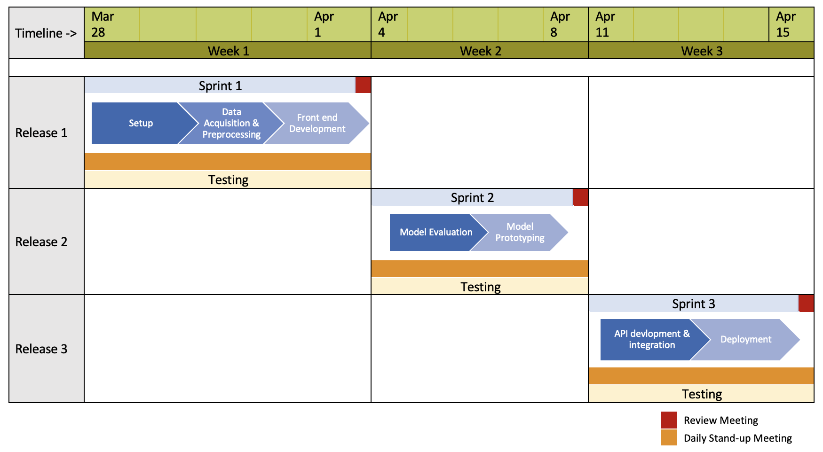

***Agile Gantt Chart***

DECLARATION

I certify that the dataset we have chosen to work on our final project have not be used in any of my prior courses in the AIDI program. We understand as a group that, if any student in the group violates academic integrity either by sharing whole or part of the group work with another group student all students in both groups will be graded to zero.

Date: 26/03/2022